September 2025
Thurs 4th | Opening night – welcome back and welcome new members.  Introduction to the new season’s programme. Short Picture Share.
Thurs 11th | Speaker: Anthony Holloway – Capturing the Aurora Borealis.  Images to Iain for printing for internal competition 1.
Thurs 18th | Picture Share 1 - Competition critique on request.
Thurs 25th | Dummy competition – Darrell / Geoff will use one of their judging competition sets. Chance to see into the mind of a judge. Entries for Internal Competition 1.

October 2025
Thurs 2nd | Internal competition 1 + Bill Duffin Open Competition.  Judge – Graham Currey.
Thurs 9th | Picture Share 2 - Competition critique on request.
Thurs 16th | Speaker: Lynda Haney – Composites. Images to Iain for printing for internal competition 2
Thurs 23rd | Speaker: Mike Sharples – People, Faces & Places.
Thurs 30th L&CPU Folio + Malcom Hart.

November 2025
Thurs 6th | Speaker: David Toliday - Astro Photography. Entries for Internal Competition 2.
Thurs 13th | Internal competition 2 + Bill Duffin Open Competition.  Judge – Roger Evans.
Thurs 20th | Speaker: Andrew Astbury - High Speed Birds in Flight. https://wildlifeinpixels.net/index.html
Thurs 27th | 5 Towns Competition – Crewe.
December 2025
Thurs 4th | Photo Poker - Rob Hockey.
Thurs 11th | L&CPU Folio & Party Food (Food TBC).
Thurs 18th | No Meeting.
January 2026
Thurs 1st | No Meeting.
Thurs 8th | Open evening – questions and answers
Thurs 15th | External Competition with Crewe at Crewe - Judge TBA. Images to Iain for printing for internal competition 3.
Thurs 22nd | Picture Share 3 - Competition critique on request.
Thurs 29th | Speaker: Jim Holmes - People from Around the World. https://www.jimholmes.co.uk/portfolio  Entries for internal competition 3.
February 2026
Thurs 5th | Internal Competition 3 + Bill Duffin Open Competition.  Judge - Lee Sutton.
Tues 10th  Thurs 12th | Holmes Chapel and Knutsford External at Knutsford.  Millennium Inter-Club Competition – Leek CC.
Thurs 19th | Speaker: Geoff Reader - How to be a Portrait Photographer. Images to Iain for printing for Internal Competition 4.
Thurs 26th | Speaker: Jason Rowley – Nature Photography

March 2026
Thurs 5th | Picture share 4 – competition critique on request.  Entries for internal competition 4.
Thurs 12th | Speaker: Robert Millin MFIAP, FBPE, EFIAP/d3, MPSA, DPAGB, SPSA, GPU Zeus, AWPF, LRPS - More Confessions of a Competition Addict.
Wed 18th | External Competition - Mid Cheshire at Winsford.
Thurs 19th | Internal Competition 4 + Bill Duffin Open Competition.  Judge – Nick Berentzen.
Thurs 26th | L&CPU Folio + Darrell Images & Photo Tips.
Tues 31st | Nantwich External at Nantwich - Judge TBA.

April 2026
Thurs 2nd | Easter - No Meeting.
Thurs 9th | Speaker: Colin Jarvis - Mono Moods. https://colinjarvis.co.uk/
Thurs 16th | Speaker: Erica Oram - A Bit of This That and the Other.
Thurs 23rd | Home Grown Trio – Phil Raden – Still Life. David Beardmore - France 26. Andrew Donkin - South Africa.
Thurs 30th | Project - Choose your Own Theme
May 2026
Thurs 7th | Picture Share 5.
Thurs 14th | Annual competition – Judge Mike Sharples.
Thurs 21st | AGM.
Thurs 28th | Field Trip 1.

June 2026
Thurs 4th | Field Trip 2.
Thurs 11th | Field Trip 2 & 3 Picture Share.
Thurs 18th | Field Trip 3.
Thurs 25th | Field Trip 4.
July 2026  Thurs 2nd | Field Trip 3 & 4 Picture Share.

President | Muriel Dale
Chairman | Jason Rowley
General Secretary | Andrew Donkin
Treasurer | Andrew Donkin
Competition Secretary | David Beardmore
Programme Secretary | Geoff Reader
Website Officer | Darrell Oakden
Equipment Officer | Iain Malcolm
Committee Member | TBA

Meetings
Held on Thursday evenings starting at 7:30 pm (unless otherwise stated in the programme) at:
Alsager Camera Club
Linley Road
ST7 2UF

Annual Membership Fees 2025 – 2026

Adults | £30.00
Senior Citizens & under 18yr | £25.00
An attendance fee of £4.00 will be charged at each meeting.
Accompanied under 18s £1.00
Visitors may attend up to 3 meetings free of subscription and attendance fee.

Alsager Camera Club

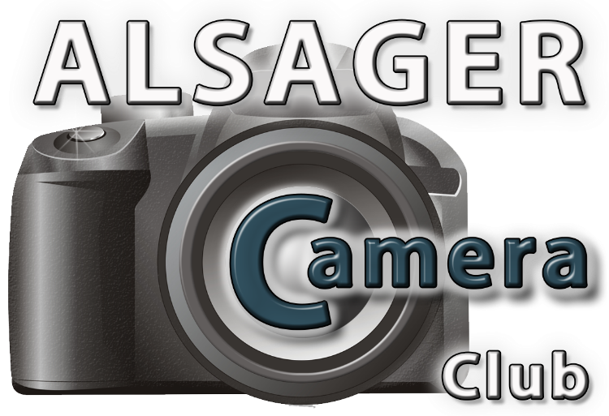

Programme of Events 2025 – 2026

(Affiliated to the Photographic Alliance of Great Britain, through the Lancashire & Cheshire Photographic Union)

www.alsagercameraclub.co.uk

