|  |  |
| --- | --- |
| **September 2022** | |
| Thurs 8th | Opening night – welcome back and welcome new members  Introduction to the new season’s programme. Short Picture Share  **Images to Iain for printing for internal competition 1** |
| Thurs 15th | **Speaker** - Justin Garner - Macro Photography  **Entries for Internal Competition 1** |
| Thurs 22nd | Picture Share 1 - Competition critique on request |
| Thurs 29th | Dummy competition - Darrell will use one of Geoff's competition sets. Chance to see into the mind of a judge. |

|  |  |
| --- | --- |
| **October 2022** | |
| Thurs 6th | Internal competition + Bill Duffin Open Competition  Judge – Mike Sharples |
| Thurs 13th | **Speaker** -Mike Lane Nature Talk **Images to Iain for printing for internal competition 2** |
| Thurs 20th | Picture Share 2 |
| Thurs 27th | Project 1 - Choose you own Theme **Entries for Internal Competition 2** |

|  |  |
| --- | --- |
| **November 2022** | |
| Thurs 3rd | **Speaker** - Ashley Franklin - The Wider World of Photography |
| Thurs 10th | L&CPU Folio + Malcom Hart TBC |
| Thurs 17th | Internal Competition 2 - Judge Paddy Ruske |
| Wed 23rd | Five Towns Mono Competition - Hosted by Mid Cheshire - Ray Hill TBC |
| Thurs 24th | **Speaker** - James Russell - Introduction to flash photography - Event at Crewe |

|  |  |
| --- | --- |
| **December 2022** | |
| Thurs 1st | **Speaker** -Brian Anderson Wild Places 2022 |
| Thurs 8th | Photo Poker - Rob Hockey |
| Thurs 15th | 2023-24 Programme discussion / Review season so far |

|  |  |
| --- | --- |
| **January 2023** | |
| Thurs 5th | No Meeting |
| Thurs 12th | **Speaker** - Brian Law - Travel Photography - Event at Crewe **Images to Iain for printing for internal competition 3** |
| Thurs 19th | External Competition with Crewe at Alsager Judge Rebecca Entwistle |
| Thurs 26th | Picture Share 3  **Entries for internal competition 3** |

|  |  |
| --- | --- |
| **February 2023** | |
| Thurs 2nd | **Speaker** - Adrian Lines - Monochrome is Not a Filter - Event at Alsager |
| Thurs 9th | Internal Competition 3 -Judge Ralph Duckett  **Images to Iain for printing for Internal Competition 4** |
| Thurs 16th | Holmes Chapel External at Holmes Chapel |
| Mon 20th | Millennium Inter-Club Competition – Newcastle TBC |
| Thurs 23rd | A Winter Walk around Rudyard + Images from ACT Geoff Reader. Second half:  What’s New in Lightroom - Iain Malcom. **Entries for Internal Competition 4** |

|  |  |
| --- | --- |
| **March 2023** | |
| Thurs 2nd | **Speaker** - Scott Latham - On the Brink - Species Conservation |
| Thurs 9th | Internal Competition 4 + Bill Duffin Open Competition  Judge – Nick Berentzen |
| Thurs 16th | Project - Choose you Own Theme |
| Thurs 23rd | Nantwich External at Alsager - Judge Gerald Chamberlain |
| Thurs 30th | Picture share 4 / L&CPU Folio |

|  |  |
| --- | --- |
| **April 2023** | |
| Thurs 6th | External Competition with Winsford at Alsager Judge Dave Tucker |
| Thurs 13th | No Meeting - Easter Weekend |
| Thurs 20th | **Speaker** – David Toliday - UK Travel Wildfire |
| Thurs 27th | Picture share 5 |

|  |  |
| --- | --- |
| **May 2023** | |
| Thurs 4th | Annual competition - Judge Mike Lawrence |
| Thurs 11th | AGM |
| Thurs 18th | Field Trip |
| Thurs 25th | Field Trip |

|  |  |
| --- | --- |
| **June 2023** | |
| Thurs 1st | Field Trip – Picture share |
| Thurs 8th | Field Trip |
| Thurs 15th | Field Trip |
| Thurs 22nd | Field Trip – Picture share |

|  |
| --- |
|  |
|  |

|  |  |
| --- | --- |
| President | Muriel Dale |
| Chairman | Jason Rowley |
| General Secretary | Andrew Donkin |
| Treasurer | Andrew Donkin |
| Competition Secretary | David Beardmore |
| Programme Secretary | Geoff Reader |
| Website Officer | Darrell Oakden |
| Equipment Officer | Iain Malcolm |
| Committee Member | TBA |

## Meetings

Held on Thursday evenings starting at 7:30 pm (unless otherwise stated in the programme) at:

Alsager Camera Club

Linley Road

ST7 2UF

## Annual Membership Fees 2022– 2023

|  |  |
| --- | --- |
| Adults | £25.00 |
| Senior Citizens & under 18yr | £20.00 |
|  |  |

An attendance fee of £3.00 will be charged at each meeting.

Accompanied under 18s £1.00

Visitors may attend up to 3 meetings free of subscription, paying only the attendance fee.

# Alsager Camera Club

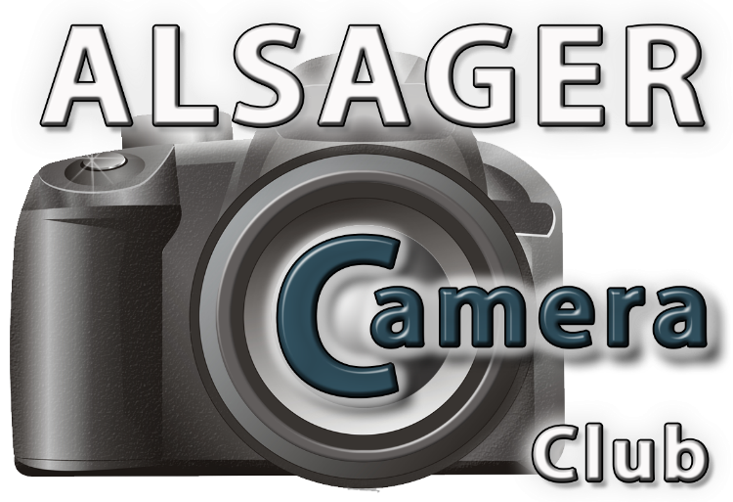

# Programme of Events 2022 – 2023

(Affiliated to the Photographic Alliance of Great Britain, through the Lancashire & Cheshire Photographic Union)



www.alsagercameraclub.co.uk